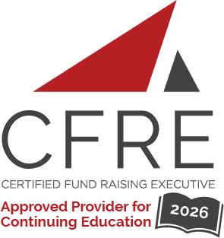  CFRE International has developed this form as a way for you to quickly track (and keep in your files!) the continuing education sessions you have attended. Simply check the boxes next to the sessions you attended. At the end of the conference, add up the total number of hours. Keep this sheet and you will be ready to complete your application form. All of the session slots listed are eligible for continuing education points on your CFRE application for initial certification and/or recertification. Sessions not listed here are not eligible for points. |  | CONTINUING EDUCATION POINTS TRACKER

Activity Organizer: - The Winnipeg Foundation
Title of Activity: - Endow Manitoba Conference 2026
Names of Presenter(s): - Various
Dates and Location: - 24-26 April, 2026 – Winnipeg, Manitoba, Canada

Date: 25 April, 2026
Session 1: 9:00am – 10:00am (1 pt)
- The Power of Us: Connection, Generosity, and Community Resilience

Date: 25, 2026 April
Session 2: 10:30am – 11:45am (1.25 pts)
- Protecting Trust in a Digital World: Practical Approaches for Cyber-Security
- Board Training: Orientation and Ongoing Board Development 101
- Working with Grant Applicants 101
- Innovative Ways to Grow Your Endowments
- Telling Your Community Foundation Story
- Leading Through Change in the Age of AI: Innovation, ethics, and Practical Action for Community Foundations

Date: 25 April, 2026
Session 3: 1:00pm – 2:00pm (1 pt)
- What Can We Do Together That We Can’t Do Alone?

Date: 25 April, 2026
Session 4: 2:30pm – 3:45pm (1.25 pts)
- Understanding and Unpacking T3010
- Youth Engagement: Empowering Young Leaders to Join Your Foundation
- Granting to Non-Qualified Donees
- The Donor Journey: Donor Stewardship 101
- Indigenous Community Engagement
- Making Social Media Work for Your Foundation

Date: 26 April, 2026
Session 5: 9:00am – 10:15am (1.25 pts)
- How an Endowment Works: Sustainable Fund Strategy (SFS) 101
- Building Leadership Continuity: Board Succession & Knowledge Transfer
- Developing Impactful Grant Awarding Practices
- Connecting Donors with Community Priorities
- Bringing Vital Signs to Your Community
- Our Stories, Our Strength: Harnessing Narrative for Community Impact

Total number of points attained: __________

