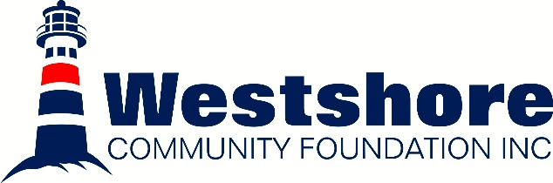
2025 Scholarship Recipients
Scholarship | Recipient | Award
The Lilja Martin Memorial Scholarship | Tessa Barkman | $430
The Lilja Martin Memorial Scholarship | Lucia Borkowsky | $180
The Lilja Martin Memorial Scholarship | Nate Borkowsky | $106
The Anna Stevens & Family Scholarship | Rebekah Aspen | $1000
Carole Ann Clark Memorial Scholarship | Haden Magnusson | $1081
The Alison Olson Memorial Scholarship & Bursary | Alyssa Gard | $1523
The Alison Olson Memorial Scholarship & Bursary | Keenan Karish | $1600
The Alison Olson Memorial Scholarship & Bursary | Elisee Moore | $1600
The Alison Olson Memorial Scholarship & Bursary | Dallas Nedotiafko | $1312
Larry & Helen Kristjanson Family Bursary | Katarina Gallo | $7157
Robert Arnason Memorial Scholarship | Abby Frost | $1000
Sigurlin Roed (Danielson) Memorial Scholarship | Ava Michaluk | $1207
Dr. Elaine Sigurdson Memorial Scholarship | Darci Mowatt | $4400
Tim & Delphine Arnason Scholarship | Amaris Toews | $2890
Ruth Ann & Wayne Furgala Family Scholarship | Erin Furgala | $500
Ruth Ann & Wayne Furgala Family Scholarship | Jahna Hardy | $500
Matthew Thordarson Scholarship | Ava Berthaudin | $1000
Brenda L. Krulicki Scholarship | Alyssa Gard | $500
Westshore Community Foundation- Interlake Eastern Healthcare Scholarship | Fawn Collins | $2875
Westshore Scholarship & Bursary | Trent Toderan | $2500
Westshore Scholarship & Bursary | Erin Furgala | $2000
Westshore Scholarship & Bursary | Jahna Hardy | $2000
Westshore Scholarship & Bursary | Morgan Meadows | $2000
Westshore Scholarship & Bursary | Dominique Chudd | $1600
Westshore Scholarship & Bursary | Mitchell Baker | $1400
Westshore Scholarship & Bursary | Zack Meadows | $1400
Westshore Scholarship & Bursary | Amber Peterson | $1400
Westshore Scholarship & Bursary | Keira Erlendson | $1000
Westshore Scholarship & Bursary | Kyra Humniski | $1000
Westshore Scholarship & Bursary | Leif Robak | $1000
Westshore Scholarship & Bursary | Vira Balaban | $500
Westshore Scholarship & Bursary | Averi Kornelsen | $500
Westshore Scholarship & Bursary | Ava Michaluk | $500
Westshore Scholarship & Bursary | Lilah Pinsent | $500
Westshore Scholarship & Bursary | Dallas Nedotiafko | $88
Westshore Trades & Technology Scholarship | Presley Tarnowski | $1450
Westshore Trades & Technology Scholarship | Rhianne Clarke | $1000
Westshore Trades & Technology Scholarship | Callie Sylvester | $1000
30 Scholars Awarded a Total of $52, 983

