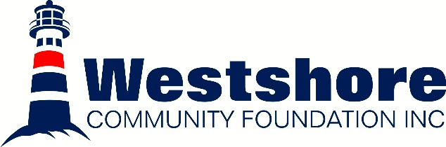
2025 Grant Recipients
Recipient | Cause | Grant
Gimli Wetland Initiative | Wetland Development | $16, 740
Gimli Children’s Centre | Building Upgrades: Siding & Doors | $11, 000
Betel Heritage Foundation | Stefanson Hus Assisted Living | $10, 000
Gimli Fire & Rescue | Wildland Fire & Hazmat Trailer | $7000
New Iceland Heritage Museum | Centennial Celebrations | $4860
Gimli Glider Museum | Cockpit Restoration | $4500
Betel Heritage Foundation | Johnson Hall Projector | $4500
Camp Arnes | Pool Restoration | $4500
Minerva Ladies Aid | Wheelchair Accessible Bathrooms | $4200
Evergreen Basic Needs | Shelving Units & Tables | $3600
Sleep in Heavenly Pease | Closed in Trailer for Bed Transport | $3500
Gimli Barvinok Dance | Ukrainian Costumes & Culture Enrichment | $2800
Interlake Eastern Health Foundation | Bladder Scanner | $2700
Lake Winnipeg Research Consortium | Lake Winnipeg Consortium Open House & Namao 50th Birthday | $2500
Fraserwood Hall | Community Play Structure | $2500
Riverton Bifrost Parks & Recreation | Beautification of Baseball Fields | $2250
Matlock Recreation Club | Community Caregiver Program | $2100
Riverton Cemetery | Accessibility Parking & Bridge | $2100
Gimli New Horizons | Chair Replacements | $1800
Interlake Women’s Resource Centre | Cultural Healing & Self Care Sessions | $1750
The Sandy Hook Pier | Accessibility & Limestone Piers | $1500
Gimli International Film Festival | World Environmental Day | $1440
Betel Home Foundation | Accessible Shower Chair | $1400
RM of Gimli: Recreation & Leisure | Gimli Musical Theatre | $1400
Gimli International Film Festival | Purchase of a PA System | $1005
Gimli Ice Festival | 15th Anniversary Video | $750
Meleb Park Cumming School Reunion Committee | Accessibility Ramp for Washroom Facilities | $490
Culture Days | Nuit Blanche | $250
28 Organizations for a 2025 Granting Total of $103, 135

